Staffordshire Police - Role Profile
Role Title: Technology Manager (Projects)

Grade/Rank: | K
Command: | Enabling Services – Digital, Data and Technology (DDaT)
Reports to: | Head of Technology – Strategy and Transformation
Direct Reports: | IT Programme Manager, Senior IT Project Managers, IT Project Managers, Technical Business Analysts, Project Support Analyst, QAT Senior Analyst
Job ID (Internal use only) | 00118768

Role Purpose
Digital, Data and Technology (DDaT) are responsible for transforming and supporting all of the force's digital technology needs.

The Project team are responsible for overseeing and coordinating all major change or transformation activity across the DDaT Department. This includes project delivery, project resource scheduling, test engagement and planning, and portfolio planning.

Aspects include
- Resource Planning and levelling
- Project Planning and management
- Reporting and Recovery
- Milestone and benefits tracking
- Regular monitoring through Lifecycle

This role holds responsibility for ensuring all DDaT projects are managed, coordinated, governed and successfully delivered. Regular dashboard reporting on project status and progress is an essential expectation of the role, alongside risk management and benefits tracking. This role will work closely with the Strategic Change Team to support wider organisational delivery which includes DDaT workstreams.
In order to ensure the on-going effectiveness of DDaT project delivery, the post holder will need a good understanding of project management and ITIL best practices and be familiar with different approaches, as well as ensuring that project deliverables are well documented and understood throughout the department.

Key Tasks, Accountabilities and Responsibilities:
• Effective leadership and management of the Transformation team;
• Manage the governance, planning, costing and delivery of the force’s IT projects;
• Produce regular oversight dashboards and highlight reports on project delivery performance, both at an individual level and across the broader IT programme of work;
• Be actively involved in senior stakeholder engagement across the force to ensure effective project management and customer satisfaction;
• Oversee the control of high-value project budgets, as delegated;
• Manage relevant project risks, benefits realisation, lessons learnt;
• Act as an escalation route for project delivery issues;
• Monitor and manage delivery milestones and performance standards for the projects/transformation team;
• Requires a breadth of technical awareness across core pillars of DDaT (Services, Operations, Infra, Networks, Architecture etc)
• Ensure that all sustainment and adaptive changes are managed and coordinated effectively, following ITIL (or similar) best practices;
• Establish routine engagement with other DDaT Managers to ensure that project resources are being scheduled and do not exceed capacity;
• Help facilitate the forecast demand for technical resources in support of project delivery, and ensure that they are scheduled effectively throughout the implementation of the project;
• Liaise with suppliers and external contractors over the delivery of project dependencies and act as a point of escalation where necessary;
• Establish robust analytical approaches to defining the scope of projects, facilitating the engagement with end users to ensure that all requirements are known;
• Where necessary, implement clear systems testing procedures to assess readiness of major system changes before commitment to live environments;
• Provide specialist information and/or advice to assist and influence senior colleagues/customers to make decisions relating to significant business issues;
• Revise or develop procedure and policy for approval and contribute to their successful implementation in order to steer project management best practice approaches across the team;
• Assist the Head of Strategy & Transformation in formulating strategic direction for the team;
• Prepare business cases or reports, including making recommendations for improvement projects within the team;
• Ensure the team continually promote the DDaT function through engaging with operational managers wherever possible;

Essential Qualifications, Skills and Experience | Stage Measured:  (A) = Application  (T) = Test/Assessment  (I) = Interview
Essential Qualification(s) | A | T | I
IT qualification in Project Management or technical discipline(s) | 
Essential Skill(s) and Essential Experience | A | T | I
Significant demonstratable experience managing project delivery teams
Demonstratable track record of Portfolio, Project and Programme delivery inc. Transformational sized change
Experience of writing and presenting performance reports to senior stakeholders
Experience of portfolio optimisation across a large volume of change
Enterprise resourcing experience

Special Conditions:
Full UK Driving Licence Required | Yes | Flexitime Role | Yes
Driving Licence Category | Full | Agile Role | Yes
Own car for business use | Yes | Fixed Location Role | No
Vetting level required: RV, MV, SC | MV | Fixed Hours | No
Politically Restricted Y/N | No | Shift allowance | No
Fixed term or temporary role | No | On call/standby rota | No
Notice Period Staff: 1 or 3 calendar months | 3 | Weekend working expected | No
Notice Period Officer: 28 Days |  | Requirement to wear Uniform | No
Requirement for a Learning Agreement | No | Budget Level Holder Y/N | No
Personal Safety Training Required in Role | No | First Aid Required in Role (Emergency life support) | No
Requirement for Professional Registration/Licence/Continuous Professional Development (CPD)* | No | *(if yes provide details here)

Behaviours - Competency & Values Framework for Policing (CVF)
The Competency and Values Framework will be used as part of the Interview process, the three values in the CVF are derived from the ethical policing principles and support everything we do.
All roles are expected to know, understand and act within the ethical policing principles and the CVF. It plays a significant role in the recruitment, assessment, and development of officers and staff at every level.

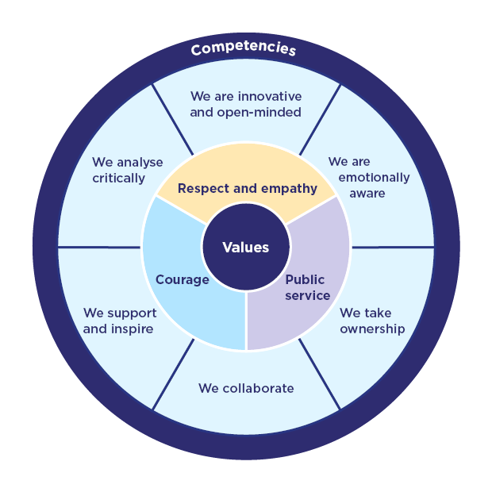
The framework has 6 competencies aligned to 3 core values. Under each competency there are three levels that show what the behaviours will look like in practice.

- Level 1 – Practitioner
- Level 2 – Supervisor/Middle Manager
- Level 3 – Senior Manager/Executive

This role is expected to operate at the levels shown below for each competency
Competency | Level
We are innovative and open minded | 3
We are emotionally aware | 2
We take ownership | 3
We collaborate | 3
We support and inspire | 3
We analyse critically | 3
Digital, Data and Technology Professional / Capability Framework
roles in government, and the skills you need to do them
Each role level in this framework includes a list of required skills. Each skill is assigned one of 4 skill levels, reflecting the required proficiency:
1 Awareness, 2 Working, 3 Practitioner or 4 Expert.
Communicating between the technical and non-technical | 3 | Community collaboration | 4
DDaT perspective | 3 | Enterprise and business architecture | 2
Governance and assurance | 4 | Making and guiding decisions | 4
Life cycle perspective | 4 | Financial ownership | 3
Planning | 4 | Maintaining delivery momentum | 3
IT infrastructure | 2 | User focus | 2
Technical understanding | 2 | Agile and Lean Practices | 4

Skills for the Information Age (SFIA)
The global skills and competency framework for the digital world
Autonomy | Influence | Complexity | Business Skills | Knowledge
Level 5 | Level 5 | Level 6 | Level 5 | Level 4
1 – Follow | 2 – Assist | 3 – Apply | 4 – Enable | 5 – Ensure, advise | 6 – Initiate, influence | 7 – Set strategy, inspire, mobilize

Reference Data Only – DO NOT SAVE AS PART OF ROLE PROFILE

Competency & Values Framework 2024

Level | Police | Staff | Remarks
1 | Trainees, Admin Roles | D Grades | Practitioner
1 | PCSOs, PCs | E Grades | Practitioner
1 |  | F Grades | Practitioner
2 | Sergeants | F Grades | Supervisor/  Middle Manager
2 | Inspectors | G Grades | Supervisor/  Middle Manager
2 | Chief Inspectors | H Grades | Supervisor/  Middle Manager
2 |  | I Grades | Supervisor/  Middle Manager
3 | Superintendents | J – M  Grades | Senior Manager
3 | Chief Superintendents | J – M  Grades | Senior Manager
3 | Executive | Executive | Senior Manager

