Job Description

Directorate: | Place
Service: | Highways & Transport
Location: | County Hall, Preston / Hybrid
Salary range: | £108,696 - £117,998 pa | Grade: | LCC D2
Reports to: | Executive Director of Place | Staff responsible for: | TBC

Job purpose and scope
The Director of Highways and Transport is a critical role at Lancashire County Council, designed to develop, implement, and promote effective policy, strategies, and interventions for the efficient and cost-effective delivery of a range of critical infrastructure, operations, and service provision, including managing and developing the council's highways asset network.

The Director will develop strategic policies, lead, and embed change and deliver value for money for the communities of Lancashire.

This position requires a visionary leader who can guide the highways and transport function towards achieving exceptional results while embodying the council's core values of being Supportive, Innovative, Respectful, and Collaborative. The successful candidate will demonstrate a commitment to the 'Leading Lancashire' leadership framework, ensuring excellence in highways and transport management.

The position reports to the Executive Director of Place and is a member of the Directorate Leadership Team. The role requires a high level of operational and/or technical knowledge and experience gained through broad and deep experience and academic study. The job holder will select, develop, and assess the applicability of methodology and practice using both their theoretical and conceptual understanding and their substantial experience and expertise within their service area.

As a member of the council’s senior decision-making group there is a considerable requirement for the job holder to apply evaluative judgement to determine a course of action beyond the council’s previous experience and solutions.

Performance Indicators
- Responsible for the delivery of key performance indicators and standards of practice.
- Quality of service and compliance against statutory, regulation and best practice standards and requirements.
- Achievement of service wide objectives and targets.
- Delivery of joint performance indicators and standards of practice with partners and multi-agencies.
- Leading Lancashire Framework

Leadership Responsibilities and Expectations
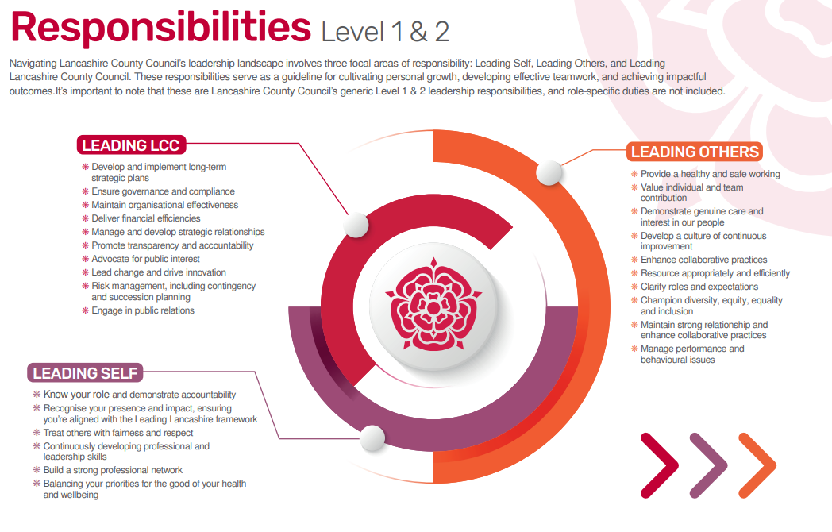

Role-specific accountabilities/responsibilities:
- Deliver strategic, decisive, influential leadership and direction to ensure the combined efforts of internal resources and external partners and stakeholders are effectively co-ordinated.
- Deliver a range of infrastructure, operations, and service provision, including managing and developing the council's highways asset, network, fleet, and transport services across Lancashire.
- Lead the efficient and cost-effective delivery of a range of critical infrastructure and service provision including highways and transportation networks that meet the needs of Lancashire residents and businesses and discharges all statutory requirements.
- Drive the continuous improvement of services within the relevant service areas and deliver a responsive business model and workforce able to quickly evolve and adapt to new ways of working in response to changing priorities and needs.
- Lead on the development of internal and external partnership working with strategic partner organisations and key stakeholders working in collaboration to deliver effective services within the relevant service areas.
- Contribute to a strong and cohesive senior leadership group, role model the organisation’s values and behaviours.
- Lead the council's strategies relevant to their service area and ensure the delivery of high quality, best practice, and value for money services to communities and citizens.
- Provide advice and guidance to members and senior managers on the implications of new legislation, policies, and any other major external and internal drivers for change and to ensure the effective implementation of required changes.
- Responsible for the service area budget and delivery of high quality, value for money services within the budgetary parameters.
- Lead the co-ordination and integration of Highways; Public and Integrated Transport; and partnerships across the wider organisation in line with longer term strategic plans.
- Influence internal and external partners and key stakeholders including representatives at a regional level and in central government to ensure delivery against service specific and corporate objectives.
- Lead and direct the development and maintenance of a motivated, performance focused workforce that is trained, professional, effective, and committed to the success of the operating model and service standards.
- Develop and implement strategic business plans in line with the core purpose and objectives of the Place Directorate.
- Ensure robust systems are in place to maintain and produce accurate and timely data required for statutory compliance, monitoring against performance standards and evaluation of service delivery.
- Play an active role in civil contingencies activity.
- Strategically contribute to and lead on the delivery of council wide objectives and projects to support the council's future vision and operating model.

Other
Equal Opportunities
We are committed to achieving equal opportunities in the way we deliver services to the community and in our employment arrangements. We expect all employees to understand and promote this policy in their work.

Health and safety
All employees have a responsibility for their own health and safety and that of others when carrying out their duties and must help us to apply our general statement of health and safety policy.

Customer Focused
We put our customers' needs and expectations at the heart of all that we do. We expect our employees to have a full understanding of those needs and expectations so that we can provide high quality, appropriate services at all times.

Safeguarding Commitment
We are committed to protecting and promoting the welfare of children, young people and vulnerable adults.

Skills Pledge
We are committed to developing the skills of our workforce. All employees will be supported to work towards a level 2 qualification in literacy and numeracy if they do not have one already.

Our Values
We expect all our employees to demonstrate and promote our values:

Supportive
We are supportive of our customers and colleagues, recognising their contributions and making the best of their strengths to enable our communities to flourish.

Innovative
We deliver the best services we possibly can, always looking for creative ways to do things better, putting the customer at the heart of our thinking, and being ambitious and focused on how we can deliver the best services now and in the future.

Respectful
We treat colleagues, customers and partners with respect, listening to their views, empathising and valuing their diverse needs and perspectives, to be fair, open and honest in all that we do.

Collaborative
We listen to, engage with, learn from and work with colleagues, partners and customers to help achieve the best outcomes for everyone.

Person Specification

All the following requirements are essential unless otherwise indicated by *

Your ability to meet the job requirements will initially be assessed by the information provided on your application but further assessment will be undertaken at interview and, in some cases, by using other types of assessment(s).

Qualifications
- Honours Degree level qualification in a relevant field or equivalent experience.
- Relevant professional/management qualification or equivalent.

Experience
- Significant leadership, experience, and delivery of major operational services within a complex organisation.
- A demonstrative record of achieving and delivering services judged to be good or outstanding.
- Successful leadership and delivery of large-scale change programmes and management of reducing resources.
- Successful development of multi-agency partnership and collaborative working, to enhance service delivery and maximise best value benefits.
- Successful development of strategic solutions and outcomes to meet statutory requirements, regulations, improved service standards and in response to existing and emerging priorities.

Essential knowledge, skills & abilities
- Extensive knowledge and understanding of local government and of the areas of responsibility.
- Ability to lead, manage and motivate services/teams in a challenging and changing environment.
- Excellent understanding of the political context at a local, regional, and national level and the ability to operate sensitively and efficiently within a political environment.
- Strategic and analytical thinking skills to provide creative and fit for purpose solutions to problems within the area of responsibility.
- Ability to work collaboratively, as part of the senior leadership group, and take shared responsibility for organisational performance.
- Ability to build, maintain and influence effective working relationships both internally and externally with key stakeholders and partners.
- Provision of strategic direction within the relevant area of responsibility in an environment of reducing financial resources.
- Highly developed interpersonal and communication skills.

Personal Attributes
The Lancashire Mindset
Demonstrate Growth, Ownership, Optimism, and Positive Impact in all actions and decisions.

Values-Aligned Capabilities and Behaviours
Reflect the council's core values through supportive, innovative, respectful, and collaborative practices.

Other Essential Requirements
- Commitment to Diversity & inclusion through the ongoing development of an Incisive workplace.
- Commitment to health and safety.
- Display the LCC values and behaviours at all times and actively promote them in others.
- This is an essential car user post.

