Job Profile

Job Title: Head of ASC Insight, Quality & Financial Services
Job Grade: Level 6 Zone 2

About Camden
Camden is building somewhere everyone can thrive, by making our borough the best place to live, work, study and visit. We’re not just home to UK’s fast-growing economy, we’re home to the most important conversations happening today. And we’re making radical social change a reality, so that nobody gets left behind. Here’s where you can help decide a better future for us all.

The Head of ASC Insight, Quality and Financial Services is responsible for leading a range of teams, including performance, resource coordination and awards and contributions, direct payments, personal finance services, welfare rights and business analytics. The role will be responsible for monitoring quality assurance across the service, instilling an evidence-based performance culture within Adult Social Care and fostering a culture of continuous service improvement.
The Head of ASC Insight, Quality and Financial Services is a key member of the leadership team within Adult Social Care (ASC). ASC is a part of the ‘Supporting People’ Directorate within Camden Council.
The post holder will report directly to the Director of Adult Social Care. The post holder will provide management support to managers across a range of teams within Performance and Support Services. Please see the structure chart below.
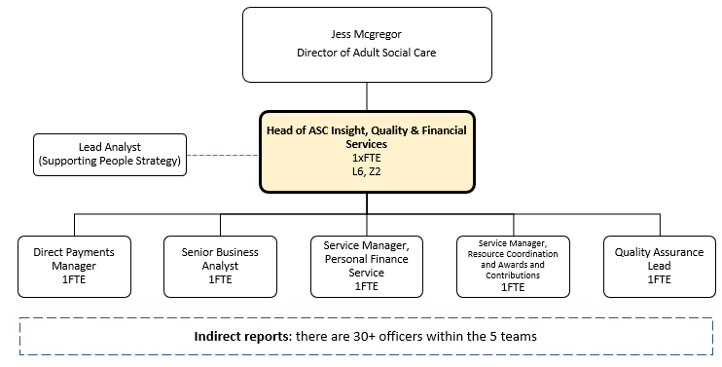

About the role
Role Purpose:
- To be a key member of the ASC leadership team, helping to drive transformational change and deliver excellent services for people in Camden.
- To lead a team of Managers by inspiring and engaging the team, to ensure the successful delivery of priorities set out in Supporting People Connecting Communities, We Make Camden and The Way We Work.
- To work effectively with Service Managers and Heads of Service across ASC, to improve the use of information and evidence, and to develop quality performance & outcome frameworks which instil excellent customer service.
- To ensure staff and managers across ASC have information available hand that accurately illustrates service quality and performance in order to drive improvement and demonstrate the impact of good practice and change/transformation.
- To understand political and economic drivers, to be able to influence key stakeholders and to shape the vision for the service.
- To empower staff and partners and embed innovative approaches to drive high standards, quality, and value for money.
- To effectively manage divisional budgets, to deliver value for money services and to ensure the delivery of savings within the Medium-Term Financial Strategy (MTFS).
- To actively ensure that business processes within the division are effective and result in accurate data on social care and other corporate systems and to use performance and financial data alongside resident experience to inform decisions.
- To establish performance systems which support legislative, regulatory, and best practice ways of working, including Safeguarding adults.
- To scan the environment for the latest thinking, tools, and technology to ensure the delivery of high-quality services - compliant with legislation and ASC priorities (e.g., the Supporting People, Connecting Communities strategic plan).
- To ensure purchasing of all ASC provision is managed effectively and efficiently and delivers value for money.
- To ensure that management information accurately informs financial and service planning, and that business processes (including payment of providers) is timely and informs ASC budget setting.
- To work with all ASC SMT members in partnership to develop and deliver on a holistic ASC Quality Assurance Framework, despite the lines of accountability sitting with individuals.
- To work with all ASC SMT to monitor spend, performance and impact on outcomes, recognising a collective responsibility for the effectiveness of the ASC system
- To work with all ASC SMT to evaluate the effectiveness of budget and quality management and plan together actions to drive required change.

Example outcomes or objectives that this role will deliver:
The postholder will:
- Work with stakeholders and gather intelligence (social care, health, political, economic etc) to set the direction and delivery of outcomes for Performance and Support Services.
- Challenge the performance of teams and work in partnership with operational Managers to deliver excellent services.
- Utilise their specialist knowledge of services for people with complex needs and vulnerabilities, to prepare reports for senior leaders and Members.
- Show effective collaboration with internal and external stakeholders, to ensure a whole council approach to living and ageing well in Camden, as well as supporting the achievement of strengths-based outcomes.
- Support Operational Managers by providing key data and trends to support service development.
- Implement the key aspects of the strategies for service users and carers who are the responsibility of the London Borough of Camden and to deliver CCG priorities.
- Use their expertise and knowledge to lead public consultations and represent the council on a local, regional and national basis.
- Be responsible for data for Safeguarding of vulnerable adults within the services provided and oversee business continuity planning for Performance and Support Services.
- Empower Managers to be innovative and provide learning and development opportunities for Managers.
- Be responsible for effectively managing budgets (including joint budgets with health partners), financial performance and efficiency savings.
- Identify and reduce structural inequalities.
- Ensure legal compliance (e.g., Data Protection) and ASC legislation, more broadly.
- Contribute to overall planning for Adult Social Care and relevant health plans.
- Lead on the financial reconciliations required around provider payments and developing sound arrangements for the accruals of care services.
- To deliver out of hours direction and leadership as part of the senior leadership team weekly cover arrangements.

About you

Qualifications:
Degree level qualification and/or 5 years' experience of performance management or ASC support services.

Technical Knowledge:
Knowledge of key legislation and national policies for ASC; the Care Act, Best Value, Safeguarding Adults etc.
Good working knowledge of the legislation and Council policies covering data protection, information sharing and confidentiality.
Knowledge of approaches to successfully managing change, e.g., PRINCE2, Agile, Organisational change procedures etc.

Experience:
Experience of managing data sets, to improve service performance.
Experience of commissioning and brokerage services within ASC.
Experience of using technology; including case management systems, dashboards spreadsheet applications etc.
Experience of setting and managing large (£M+) budgets and of using data to contribute towards efficiency savings.
Experience of working collaboratively with a range of stakeholders, setting, and achieving mutually agreed, positive outcomes.
Experience of inspiring and developing multiple staffing teams, based within a variety of settings.
Experience of gathering political and economic insight to help to influence service vision and organisational strategy.
Experience of empowering staff to deliver quality services, which also offer value for money.
Experience of producing and presenting reports with complex information, for a variety of audiences.
Experience of analysing problems and arriving at innovative and user-focused solutions.

An Enhanced DBS check will be required for this role.

Work Environment:
The postholder:

- will be expected to work flexibly, as per the council’s agile working policy.
- will be based in 5 Pancras Square, but is also expected to travel to various locations in which services are located.
- will be expected to attend meetings with key stakeholders within other premises or other council offices.

People Management Responsibilities:
The postholder will provide professional expert, technical and management support to a team of Managers within Provider services. This will include supporting staff through regular team meetings and supervisions. It will also include managing ill health, managing attendance, and managing performance.

Direct Reports (5)
- Service Manager Resource Co-ordination and Awards & Contributions Team 1 x FTE
- Service Manager Personal Finance Team 1 x FTE
- Senior Business Analyst 1 x FTE
- Direct Payments Manager 1 x FTE
- Quality Assurance Officer 1 x FTE

The postholder will also work closely with the Adult Social Care Data Team and Lead Data Analyst.
Indirect Reports (30+)
The postholder may also be required to have oversight of Project Managers for the delivery of specific projects.

Relationships:
- Internal – to foster excellent working relationships within Adult Social Care and across the Council. To utilise data and intelligence and positively influence Members, including the member for Health, Wellbeing and Adult Social Care.
- External – to build effective working partnerships with residents, their family members/carers and with care providers across the borough and beyond. Particular emphasis is placed upon working closely with partners to facilitate the further integration of health and social care and including building effective partnerships and relationships with key partners in the Integrated Care Partnership (ICP)
- External Bodies – to work closely with the regulatory bodies and the charity sector, by establishing excellent service provision – seeking continual service improvement.

