Senior Advisor, Children’s Social Care
£71,330- £83,789
Purpose and impact:
The core purpose of the job is to act as the council’s lead subject matter expert in all aspects of children social care to assist the council in holding the Northamptonshire Children’s Trust (NCT) to account as the contractor responsible for the delivery of children services in West Northamptonshire (WN).
The postholder provides expert advice and quality assurance at a casework level to the chief executive (CE), director of children services (DCS) and the lead member for children services (LMfCS) of the council.
The post involves close liaison and the development and maintenance of a good working relationship with the chief executive, board chair and relevant senior officers of the Trust.
Accountable to:
The postholder supports the joint DCS / DASS in meeting the council’s statutory duties and is day to day line managed by the assistant director, commissioning and partnerships in the intelligent client function (ICF).
Responsibilities:
This job description reflects the major tasks to be carried out by the post holder and identifies a level of responsibility at which they will be required to work. In the interests of effective working, the major tasks may be reviewed from time to time to reflect changing needs and circumstances. Such reviews and any consequential changes will be carried out in consultation with the post holder.
The main responsibilities of the job to provide West Northamptonshire council with expert social care advice on the systems and procedures in place at NCT, and practice at casework level so as to make a significant contribution to the council’s intelligence on the extent to which trust activity:
- helps and protects children;
- contributes positively to the experiences and progress of children in care wherever they live, including those children who return home;
- makes arrangements for permanence for children who are looked after, including adoption;
- contributes positively to the experiences and progress of care leavers; and
- is properly prepared for all monitoring visits and inspections
- ensures that statutory responsibilities held by the council are met
Main accountabilities:
1 To lead, develop and implement a system of quality assurance at an individual case level in conjunction with the wider quality assurance approach within the ICF.
2 To examine all policies, procedures and systems in place at the trust and report to senior officers and members on their adequacy and support ICF deep dive assurance activities.
3 To advise senior officers and members about:
- the preparedness of NCT for the regulator’s quarterly monitoring visits, and focused visits if / when children services ‘requires improvement’.
- compliance with statutory duties with respect to children’s social care
- national and regional best practice and benchmarking

4 To assist the trust in its self-evaluation of social work practice on an annual basis as required by the regulator and by Operational Commissioning Group.
5 To assist in the preparation for the annual review process led by the ICF and engagement meeting and participate in the meeting as required.
6 To lead for WNC on the evaluation of the experiences of the following groups of children and young people:
- who are at risk of harm (but who have not yet reached the ‘significant harm’ threshold) and for whom a preventative service would provide the help that they and their family need to reduce the likelihood of that risk of harm escalating and to reduce the need for statutory intervention; see under * below for the relevant acts of parliament that apply);
- who have been referred to the local authority, including those for whom urgent action has to be taken to protect them; those subject to further assessment (including children subject to private fostering arrangements) and those subject to child protection enquiries;
- who become the subject of a multi-agency child protection plan that sets out the help they and their families will receive to keep them safe and promote their welfare;
- who have been assessed as no longer needing a child protection plan, but who may need continuing help and support;
- who are receiving (or whose families are receiving) social work services because there are significant levels of concern about their safety and welfare, but these have not reached the significant harm threshold or the threshold to become looked after;
- who are missing from education or are being offered alternative provision;
- looked after either by being accommodated under section 20 or by being placed ‘in care’ during or as a result of proceedings under section 31 of the Children Act 1989 and those accommodated through the police powers of protection or emergency protection orders (including children and young people who are detained, unaccompanied child migrants or asylum seekers);
- aged 16 or 17 who are preparing to leave care and meet the definition of ‘eligible’; those aged 16 or 17 who have left care and are ‘relevant’; young people aged 18 and above and are ‘former relevant’; and young people aged 18 to 25 who qualify as ‘former relevant children pursuing further education or training’, including children in houses of multiple occupation;
- who have left care to return home or who are living with families under a special guardianship order, child arrangements order or an adoption order
* (these children may be known by any person with a duty under the Children Act 2004; the Childcare Act 2006; section 175 or any regulations made under 157 of the Education Act 2002; the Borders, Citizenship and Immigration Act 2009, a member of the local safeguarding partnership; or a person associated with a commissioned service, including local voluntary services)

Our Values& Behaviours

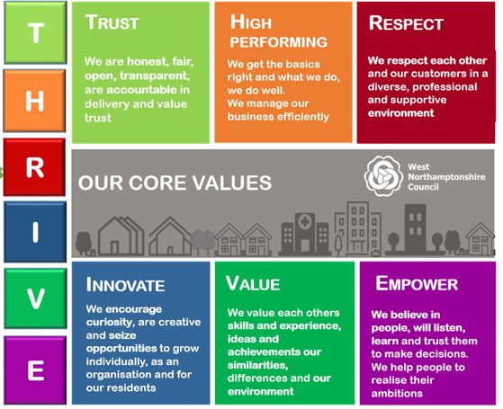

Person Specification:

The requirements for the post are outlined below and will be part of the selection process.
ATTRIBUTES | ESSENTIAL CRITERIA | DESIRABLE CRITERIA
Education and Qualifications | Degree or equivalent professional qualification or experience
 | Social work qualification or equivalent professional experience in a relevant area such as performance, quality and assurance.
Experience and Knowledge | Experience of local government policies and working practices, including working with members at cabinet level, and directors and senior officers;  Strategy formulation, writing reports and bids, and setting direction for council policy and procedures;  - Understanding and awareness of all legislation relating to social services for children and vulnerable children (for example, missing from education);  - Working with and advising senior officials and politicians;  - Working with a wide range of stakeholders within and outside the organisation to achieve agreed objectives;  - Understanding of the commissioning role and long-term risks and opportunities for the council;  Knowledge of and experience of working in a commissioning environment.
Ability and Skills | - Able to prove self-sufficiency in initiating and managing workloads;  - Able to offer expert advice on the quality of provision at a casework level;  - Evidence of a significant degree of evaluative judgement and innovative thinking to analyse, evaluate and arrive at conclusions;  - Able to work assertively at a senior officer level with commissioned organisations;  - Good report-writing ability and skills.
Equal Opportunities | Evidence of commitment to the fair treatment of all staff and clients consistent with legal requirements and council policy

