Job description and person specification
Assistant Director: Place Shaping
£85,689- £96,175
Background:

The role of Assistant Director Place shaping is a new role bringing an additional focus and opportunity in how we deliver a joined up approach into our communities.

It is responsible for delivering against our ambitious economic, regeneration and cultural plans for the area to increase the perception and reality of West Northants as a place to live, invest, do business, and thrive. The scale of the opportunity is great; a new Council, new ambition and new team, alongside strong partnerships, world renowned skills, locational advantage and huge potential.

Working closely within the Place Directorate and alongside the Assistant Director of Housing and Communities, this combined focus will develop a strong evidenced, prioritised approach across the whole of West Northamptonshire, working with our partners to deliver real change and prosperity for our residents. This will build on the significant development and work that already taken place since local government reform. Strong financial management is now seeing investment in services, towns funding has been secured and strong partnerships developed to take forward our corporate plan.

We are developing a strong dialogue with government based on an ambitious prospectus and a changing culture and focus on delivering outcomes and driving our economy. The role will also be working directly with some of the most innovative companies in the world, professional sports clubs, and a scale of development that is not happening anywhere else outside the main cities.

Accountable to:
The Director of Communities and Opportunities.
Role Purpose and Impact:

- Responsible for the overall delivery and implementation of large-scale regeneration programmes, including the £150m redevelopment as part of the Northampton Town Master Plan.

- Responsible for the development of future plans and initiatives, working with partners to maximise opportunities from funding streams including a particular focus on Levelling Up.

- Responsible for inward investment and business support across West Northamptonshire, building strong relationships with new and existing industries and sectors.

- Responsible for the development, and implementation of key strategies including economic growth, skills, visitor economy and rural economy, working closely with AD’s in assets , highways and planning to attract more investment and new business, ensuring our residents have the opportunities available in the jobs market and that visitors stay longer.
- Responsible for delivering an economic prospectus in raising the perception of West Northamptonshire as a place to do business, developing close relationships and representing the Council at a national, regional and local level.

- Responsible for the development of a cultural offer and regeneration, working nationally with acclaimed organisations to drive visitor numbers to the area and our town centres, improving the quality of our live for our residents.

- Support the Director of Communities & Opportunities to drive place shaping across West Northamptonshire, contributing to the overall corporate plan, ensuring our residents benefit from the introduction of more and better jobs and focused skills and training opportunities as well as improved environment in which they live.

- Support the Director of Communities & Opportunities in developing strong partnerships across the public sector, establishing a joined up approach to community investment and service delivery.

- Responsible for embedding an outcome-based, customer focused culture.

- Providing high level and innovative direction to the regeneration of localities within West Northamptonshire, reshaping the development and regeneration of place building on best practice and exploiting commercial opportunities.

- Responsible for leading and managing the provision and transformation of Northamptonshire’s Library Service

- Taking a proactive approach to risk management and business continuity planning on areas of accountability.

Key Relationships:

Externally: Wide network of contacts from within the public and private sectors at national and local level including stakeholders, local partnerships, council owned companies/enterprises regeneration organisations, government departments and business organisations, including council-owned companies.

Internally: Chief Executive, Elected Members, Executive Directors, Directors, Assistant Directors, and managers and teams from across the council

Key Accountabilities:

- Accountable for the delivery of the Corporate Plan and Vision of the Authority as directed by ELT and elected members

- Accountable for the delivery an implementation of the service plan to include all areas as set out in role purpose.

- Accountable for the management of capita and revenue budgets and delivery of the MTFP within area of responsibility including the effective use of Council resources

- Accountable for effectively managing and implementing change, transformation, and improvements to services as directed by ELT and elected members

- Accountable for the strategic leadership & management of all employees up to and including professional officers

- Accountable for any other corporate duties as reasonably required, including but not limited to: Briefing members, attending committee meetings; compliance with all statutory requirements and contributing to employee relation matters as defined by policy across the Authority.

The grade reflects the requirement to attend meetings outside of normal working hours.
This job description reflects the major tasks to be carried out by the post holder and identifies a level of responsibility at which they will be required to work. In the interests of effective working, the major tasks may be reviewed from time to time to reflect changing needs and circumstances. Such reviews and any consequential changes will be carried out in consultation with the post holder.

Our Values& Behaviours

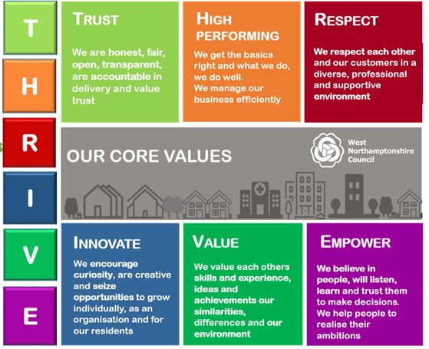

Person Specification:

The requirements for the post are outlined below and will be part of the selection process.
Education/Training
- Degree or relevant management qualification, or similar or qualified by experience.

Leadership Experience

- A proven track record of consistent and demonstrable achievement at a senior management level in the same or similar services.

- A proven track record in transforming similar services.

- Substantial post-qualification experience and a proven track record of achievement in a wide range of planning and major economic development programmes in an organisation of comparable complexity.

- A demonstrable track record of leading, motivating and managing teams to achieve high performing and significant, sustainable service improvements and outstanding results, through internal and external partnerships.

- Experience of developing and sustaining a culture that meets the needs of and engages with customers and staff within a safe, open and high-performing working environment.

- Evidence of establishing a performance management culture to drive continuous improvement, including service planning, target setting, performance appraisal and the management of staff groups.

- A track record of working in and forging successful partnerships with a wide range of internal and external bodies including governmental and non-governmental organisations, the private and voluntary sectors.

- A proven track record of working effectively within a political environment, providing clear, balanced advice and guidance on strategic and operational issues that achieve service objectives.

- A proven track record of applying commercial judgement in making decisions that will deliver cost-effective and efficient results.

- A proven track record of managing key transformation & change within complex services or areas.
Skills/Abilities

- Demonstrate a proven ability to motivate, develop teams, individual and self to enhance performance and service standards.

- Effective negotiating and influencing skills.

- Ability to build effective business Partnership, both internally and externally.

- Understanding of customer focussed services.

- Demonstrate leadership skills in managing significant change and improvement in service delivery.

- Demonstrate excellent communication skills (verbal and written) and be able to present complex issues to a range of audiences.

- Demonstrate ability to work well under pressure, achieving deadlines.

- Demonstrate ability to initiate solutions to complex issues.

- Demonstrate commitment to performance management.

Key competencies, behaviours and approach

- Prepared to quickly and flexibly react to the needs of the council, its customers and partners.

- Excellent leadership and management skills, at a strategic and operational level and including the ability to delegate appropriately.

- Strong interpersonal skills and the ability to influence and persuade.

- Strong personal commitment to the delivery of first-class services.

- High level communication, networking and ambassadorial skills.

- Business acumen.

- Vision and creativity.

- Ambitious, energetic and highly motivated.

- Visible, approachable and accessible; resilient, determined and confident.

- Awareness of own strengths and weaknesses and commitment to addressing areas requiring development.

